**Assignment 3**

Aashna Shah J042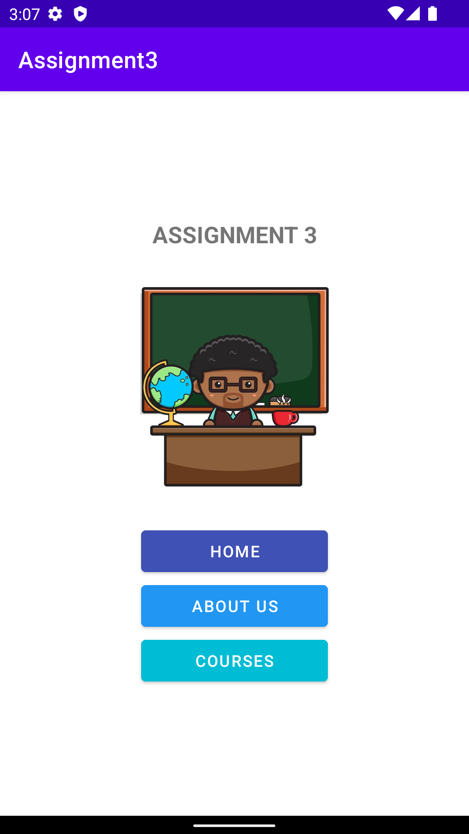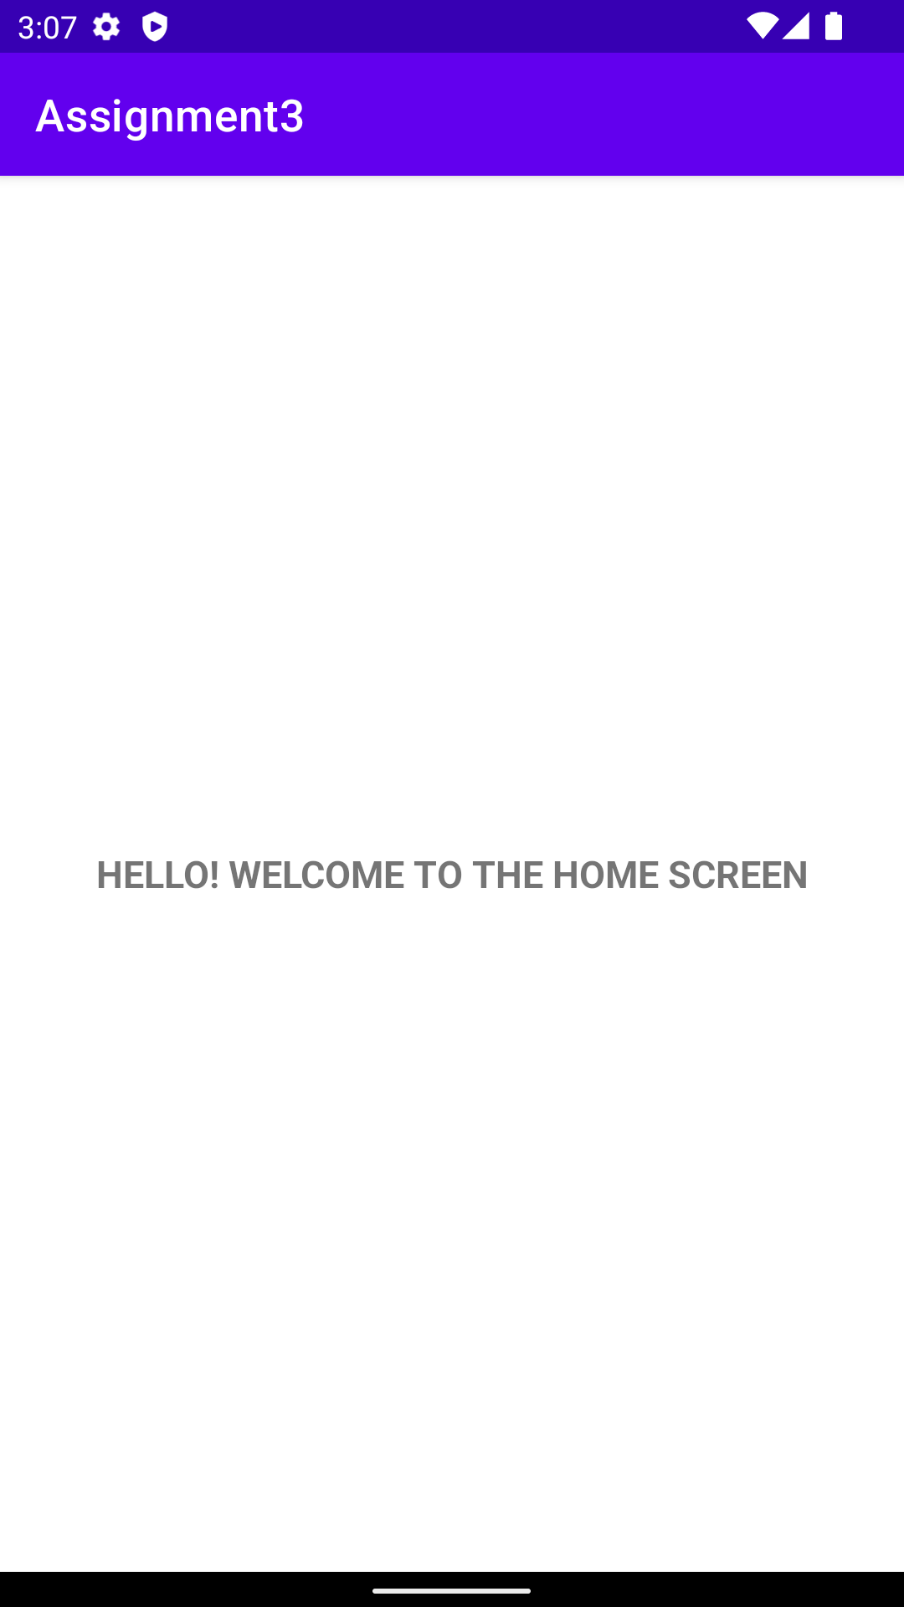

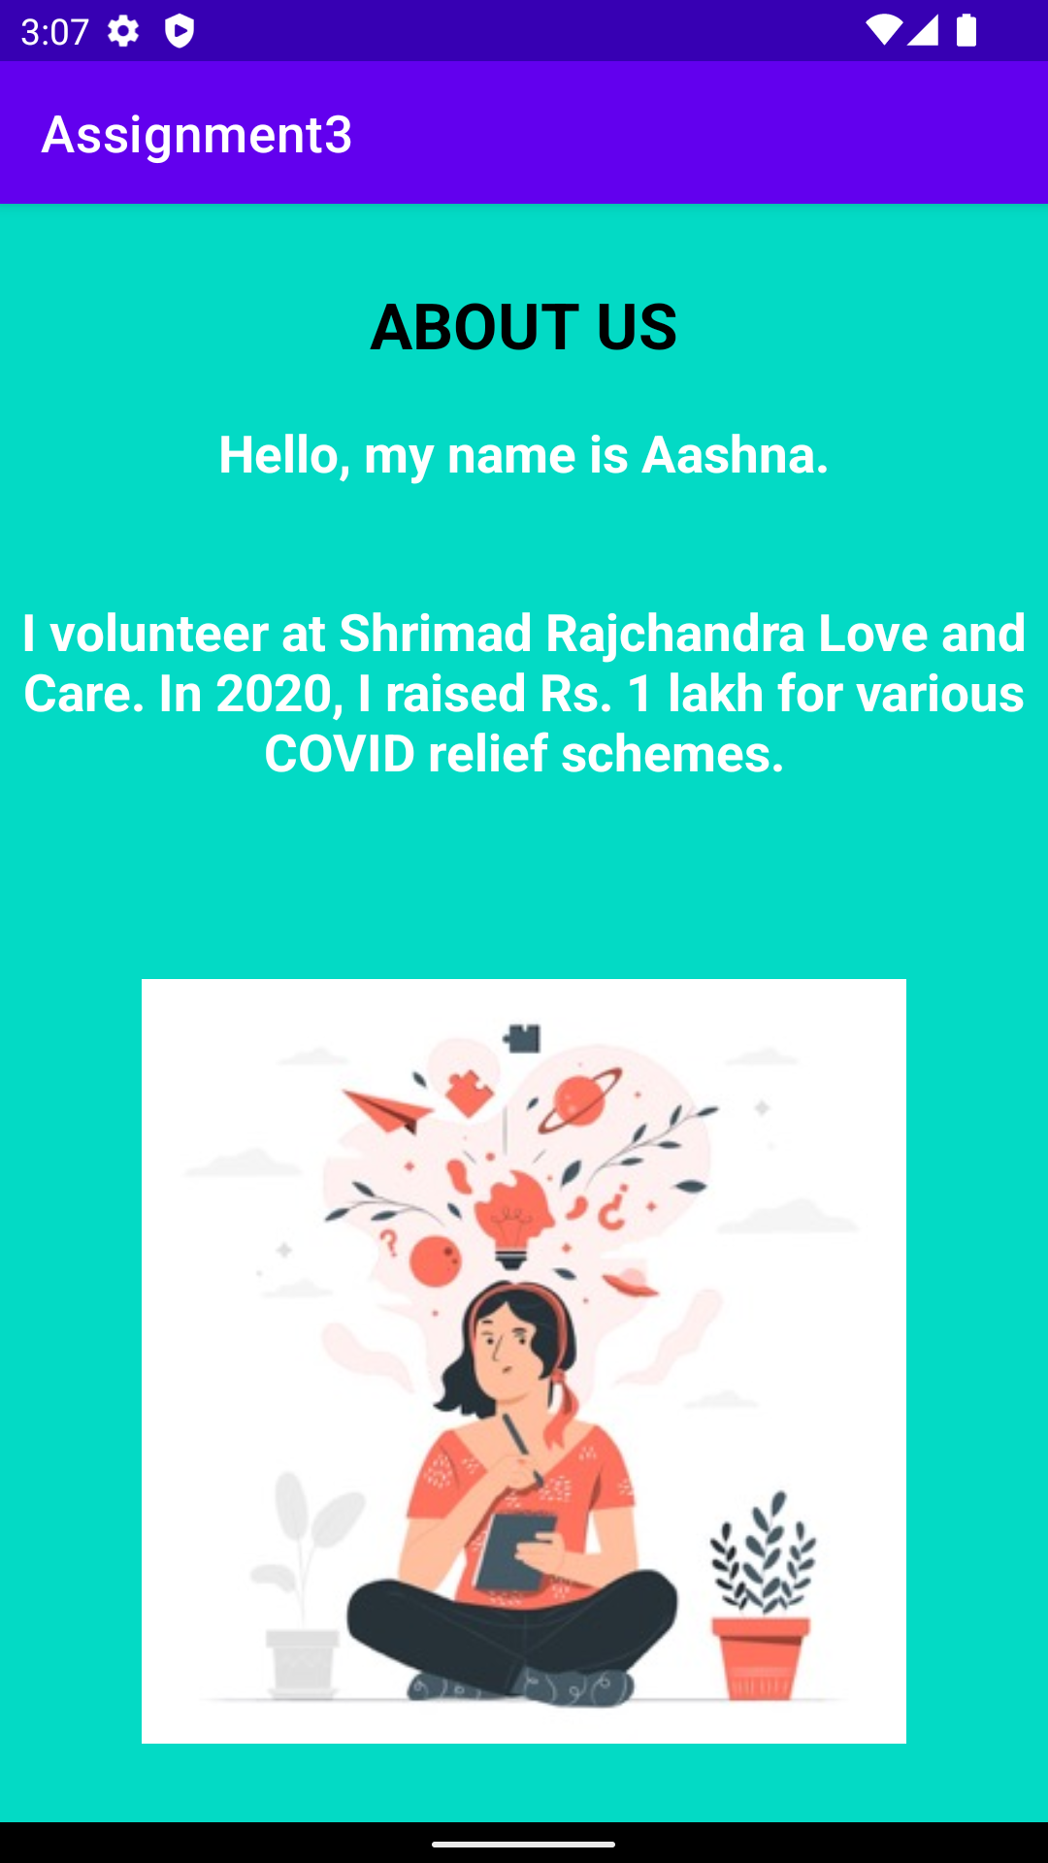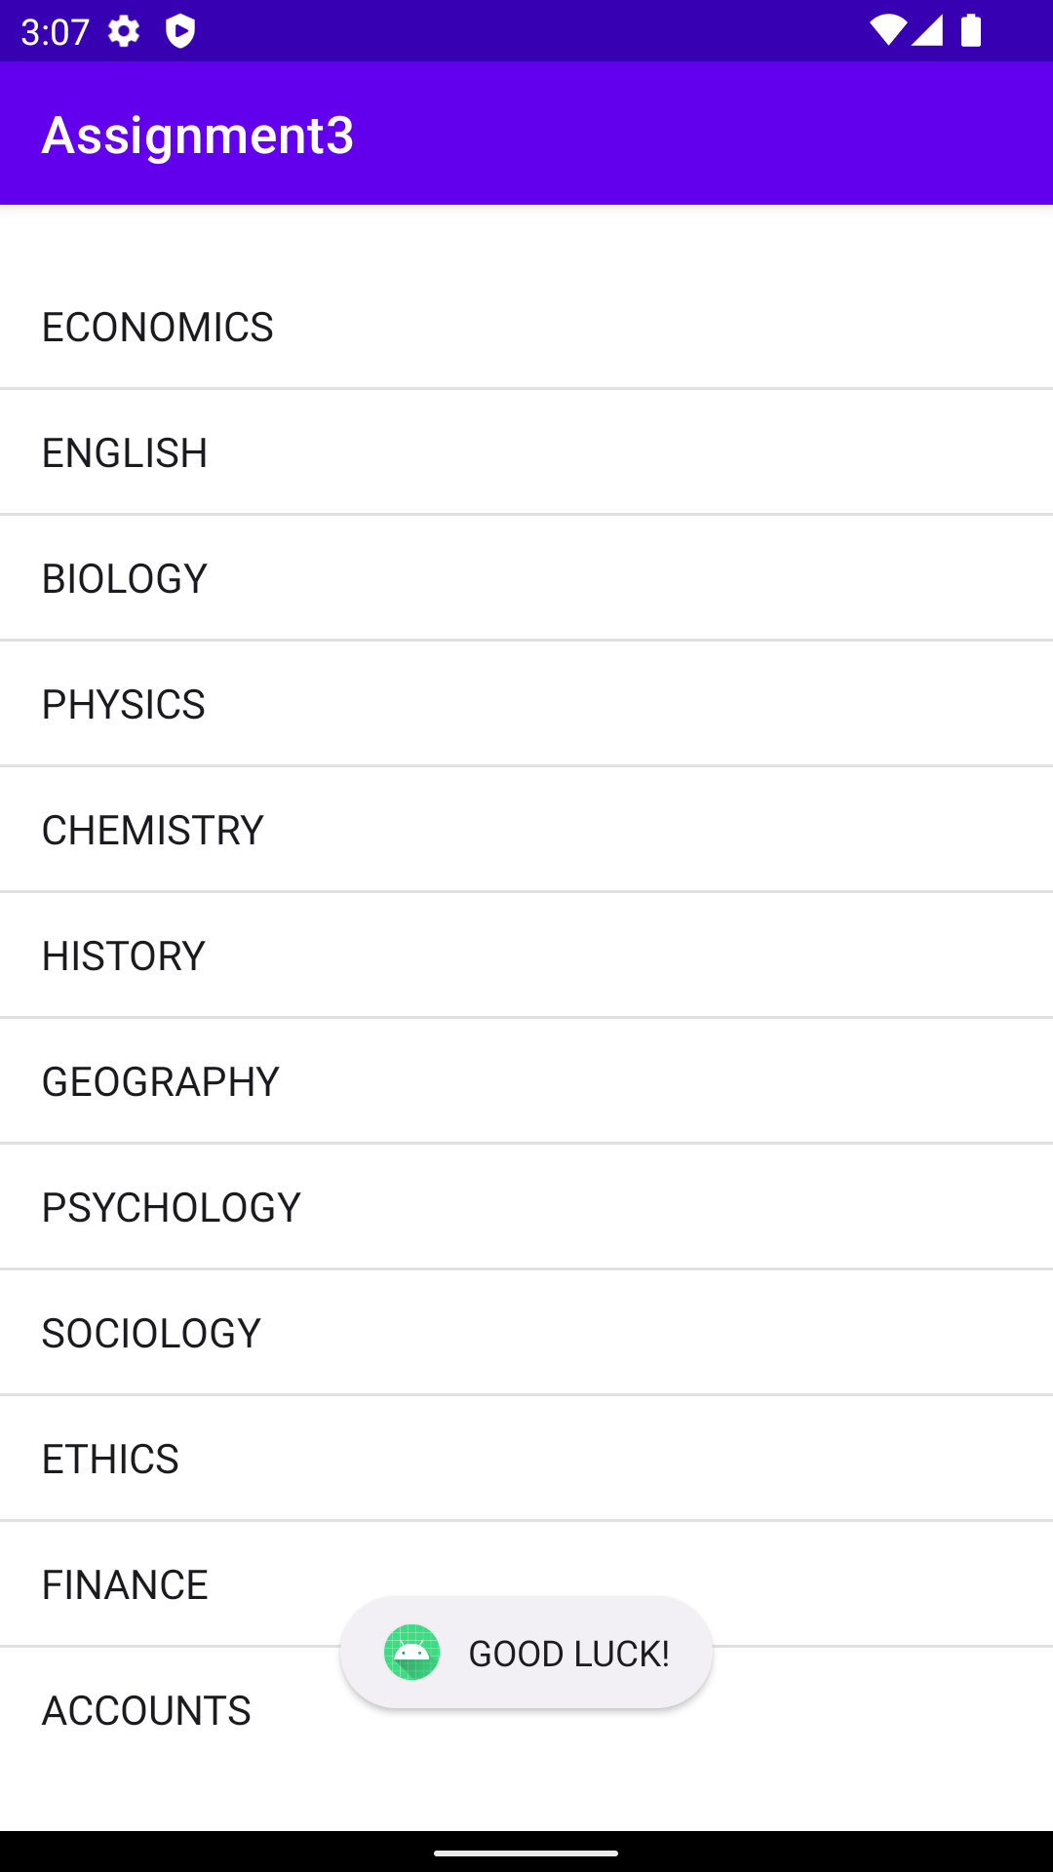

Main Activity XML

ImageImage

Main Activity Java

Home Screen XML

Image

Home Screen JavaImage

About Us XMLImage

About Us JavaImage

Courses XMLImage

Courses Java

Image